The Kobe Collection
-Historical marine meteorological data relevant to climate issues-

Climate change including global warming is an urgent and serious concern to mankind. The Intergovernmental Panel on Climate Change (IPCC) has concluded that to increase the certainty of current assessments of climate change, more complete and longer time series of climate variables such as temperature are necessary.

Although we know that the climate system has lots of natural variability, we have not been able to quantify it very well, and it is very difficult to estimate how much may be due to mankind’s influences and how much is natural. The ocean which covers 70% of the earth’s surface plays an important role in the climate system. Ocean surface data may be more suitable than land surface data for detecting smaller changes on longer time scales. Thus, climate and global change research requires the best possible knowledge of conditions at the ocean surface.

Marine meteorological observations (air temperature, sea surface temperature, air pressure, wind, etc. ) taken by merchant mariners are recorded in their ships’ logbooks, and these data extend back more than 100 years. Thus this forms one of the longest continuous climate records in existence. Historical marine meteorological observations from old ships’ logbooks are essential to the assessment of natural and anthropogenic climate changes on decadal to century time scales. We need to develop and support projects to identify and digitize as many of the historical marine records as possible. All of the international climate programmes such as GCOS,CLIVAR and WCRP have notes that this type of ‘data rescue’ or ‘data archeology’ is essential.

Kobe Collection:
The Kobe Marine Observatory, which is a field office of the Japan Meteorological Agency (JMA), collected and stored surface marine meteorological data obtained by ships over the period from 1890 to 1960: the Kobe Collection (Figure 1,2). In all, the data obtained by merchant ships, fishing boats and research vessels number about 6.8 million and those by Japanese navy ships, which cover the period from 1903 to 1944, number about 5 million. In 1961, all the data after 1933 (about 2.7 million) were digitized under a joint project of JMA and the National Oceanic and Atmospheric Administration (NOAA), and the digitized data were included in the Comprehensive Ocean-Atmosphere Data Set (COADS) Release 1 of NOAA and National Center for Atmospheric Research (NCAR).

Because there is great interest in the scientific community in the earlier observations, under the guidance of JMA, the Japan Weather Association (JWA) conducted a two-year project subsidized by the Nippon Foundation to construct a digital data base of the pre-1933 merchant ships data in the Kobe Collection in FY1995 and FY1996, taking counseling from several learned persons including Dr. Ryozaburo Yamamoto (Professor emeritus of Kyoto University). Under this project, about one million reports were digitized.

Observations in the Kobe Collection are mainly in the North Pacific, especially along the main ship routs such as Japan-North America, Japan -Hawaii-California, etc (Figure.3) For all digitized reports, 82.8%, 11.5% and 5.7% are in the Pacific, in the Indian and in the Atlantic Oceans, respectively.

Considering the data shortage during World War I, the Japan Meteorological Agency devoted its effort to digitize reports around 1916 at first. Figures 4 and 5 shows the yearly distribution of the reports of the Kobe Collection and presently available COADS in the Pacific Ocean where a large part of the Kobe Collection exists. The number of data during W.W.I. will increase greatly by the addition of the newly digitized Kobe Collection data to COADS.

Thanks to the Nippon Foundation, a new project for the digitization started in FY 1997 and it is on going in FY1998. As a part of this project, this CD-ROM is published, which contains the Kobe Collection data digitized in FY 1995 and FY1996 and quality-controlled in FY 1997.

References:
Japan Meteorological Agency, 1998: Climate Change Monitoring Report 1997 ,45pp

Komura, K., and T. Uwai, 1992: The collection of historical ships’ data in Kobe Marine Observatory, Bull. Kobe. Mar. Obs., 211, 19-29

Manabe, T. 1998: Digitization of the Kobe Collection, historical surface marine meteorological data collected by the Kobe Marine Observatory, Japan Meteorological Agency, Proceedings of International Workshop on Digitization and Preparation of Historical Surface Marine Data and Metadata, 15-17 September 1997, Toledo, Spain. H.F. Diaz and S.D. Woodruff Eds., WMO publication (in press).

Manabe, T. : The Digitized Kobe Collection, Submitted to Bull. Amer. Meteor. Soc.

Uwai, T. and K. Komura, 1992: The Collection of Historical Ships’ Data in Kobe Marine Observatory. Proceedings of the International COADS Workshop, Boulder, Colorado, 13-15 January 1992. Diaz, H. F., Wolter, K., and Woodruff, S. D., (Eds.), NOAA Environmental Research Laboratories. Boulder, Colorado, 47-59

Figure caption

Figure 1
An example of logsheet of the Kobe Collection

Figure 2
Yearly distribution of reports and ships of the merchant ship data set in the Kobe Collection.

Figure 3
Geographical distribution of the Kobe Collection reports contains in the CD-ROM. Each 2 degree latitude and 2 degree longitude box is colored according to the number of reports .

Figure 4
Yearly distribution of the reports of the Kobe Collection and COADS
in the global ocean. Red indicates the Kobe Collection data digitized in FY 1995 and FY 1996, which are included in the CD-ROM. Light blue indicates the Kobe Collection data which remain undigitized. Dark blue shows the Kobe collection data digitized in 1961, which cover the period from 1933 to 1960.

Figure 5
Same as Figure 4 except in the Pacific Ocean

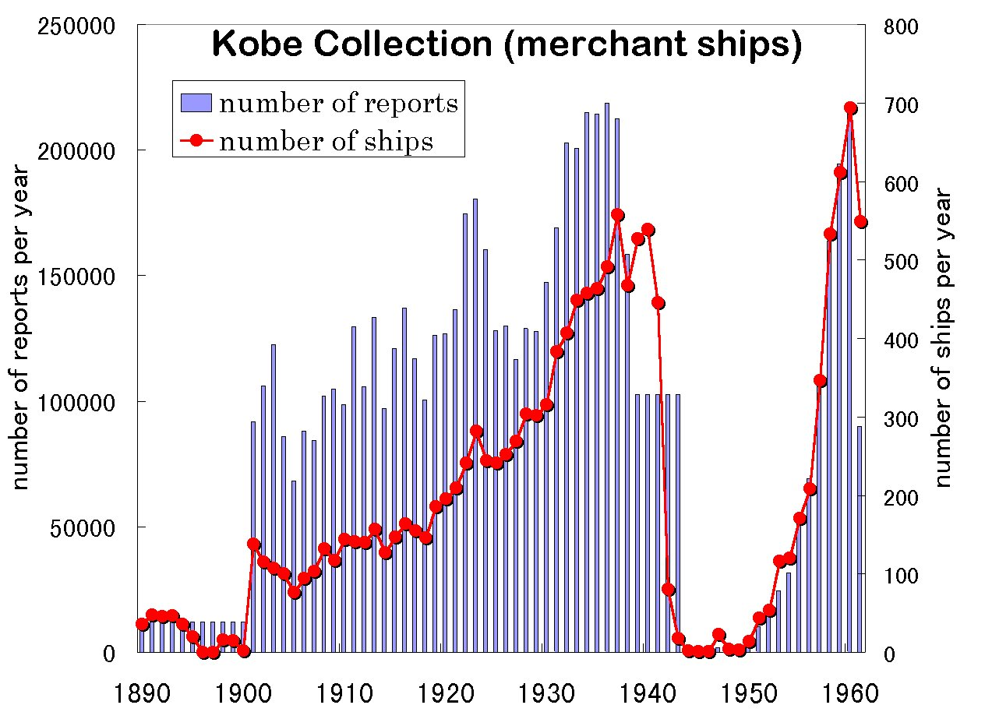
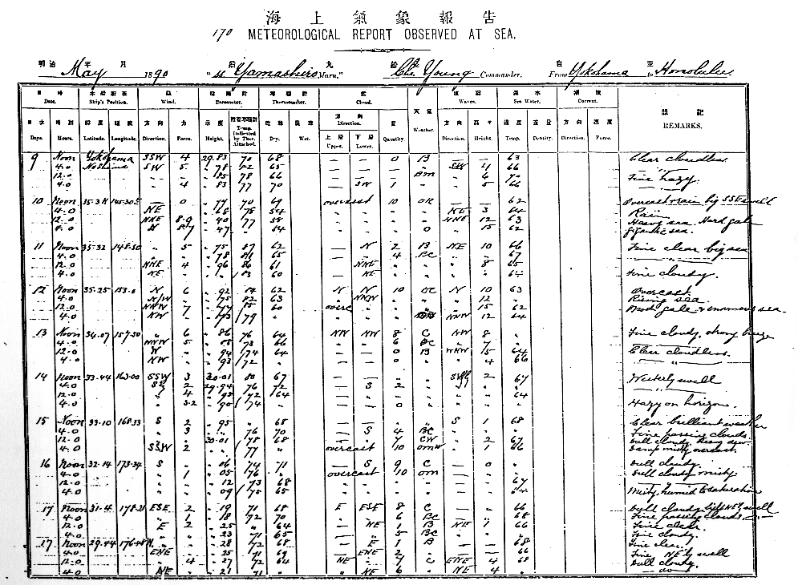

Figure 1

Figure 2
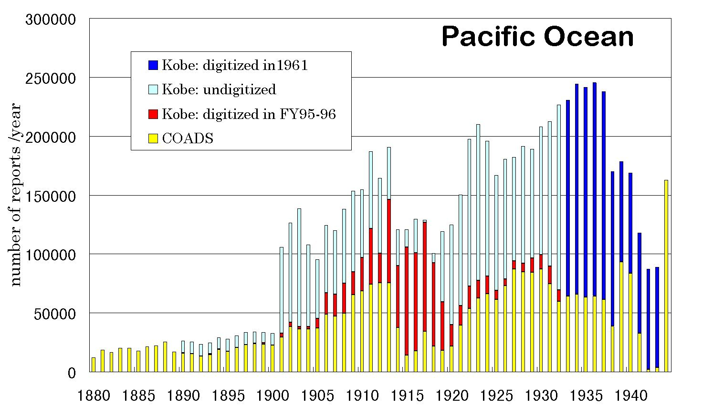
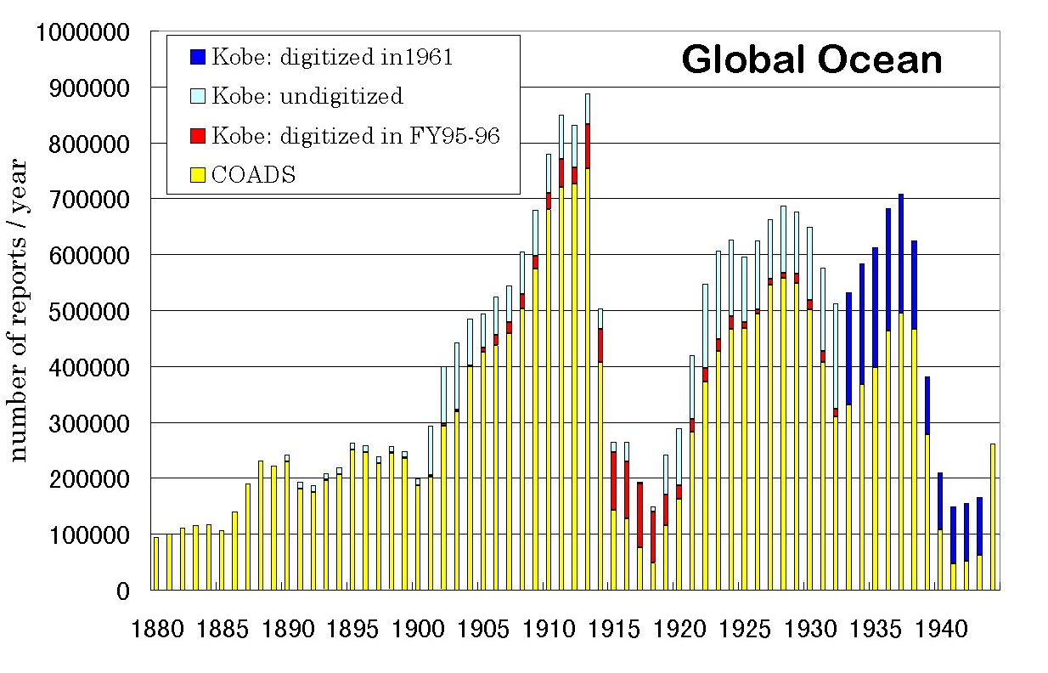
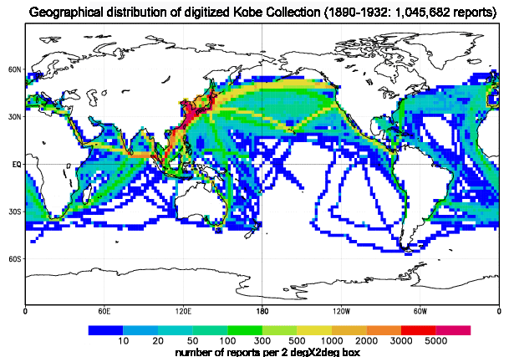
Fig1

Figure 3

Figure 4

Figure 5

